Government of India
Ministry of Science & Technology

Department of Biotechnology

(Bioinformatics Centre)


TENDER DOCUMENT

for

Request for Proposal(RFP)

Conference, Travel, Exhibition, Popular Lecture (CTEP) programme of Department of Biotechnology (DBT),
Block No.2, 6th to 8th floor,
CGO Complex, New Delhi – 110003

1

Government of India
Ministry of Science & Technology
Department of Biotechnology
Bioinformatics Centre
Block No.2, 6th to 8th Floor,
CGO Complex, New Delhi - 110003

NIT No.BT/BI/02/058/2015 Phase III Date: 9th June, 2016.

To,

All interested & eligible vendors

Sub: Open tender for DBT-CTEP Management of Department of Biotechnology
Block No.2, 6th to 8th Floor, CGO Complex, New Delhi - 110003

Dear Sirs,

- For and on behalf of the President of India, sealed tenders are invited in two (Prequalification/Technical & Financial) bids system for the subject mentioned job of the Department of Biotechnology, Ministry of Science & Technology, CGO Complex, New Delhi – 110003 for award of contract for a period of three year from the date of commencement of contract and extendable by two years or more depending upon the performance of the firm and compliance of terms & conditions stipulated in the tender document. Specification of work is given at Annexure-I.

- In case your firm is interested in the above said work, and fulfill the eligibility criteria (Appendix A), you are requested to quote your competitive prices in the enclosed Proforma (Appendix-B) in a sealed cover (Technical bid and Financial bid separately and put together both in one bigger cover and sealed) along with the documents duly signed on all pages as mentioned in the tender document in the prescribed form. The sealed cover containing the quoted tender shall be super scribed “Open tender for DBT-CTEP Management” of DBT, CGO Complex, New Delhi and be submitted by 5st July 2016 on or before 3:30 pm and shall be submitted to the Mr. J.K. Dora, Under Secretary, Department of Biotechnology, Room

No.611, Block 2, CGO Complex, New Delhi-110003.

- Pre-bid meeting shall be held on 27th June 2016 in the Committee Room No. 727 at 4:00 pm and the tenderers who wish to participate shall do so for any clarification or doubts on the program and any other details of the system. Technical bids of the Tenders received within the closing time limit shall be opened on 5st July 2016 at 3:30 pm at the same venue in the presence of such tenderers, who wish to be present.

2
- Tenderers shall submit EMD amount of Rs.50, 000/- (Rupees Fifty thousand only) in the form of DD/Pay order to be drawn in favor of DDO, Department of Biotechnology along with tender documents. The final successful tenderer shall be required to submit a performance security deposit of an amount of Rs.5,00,000/- (Rupees Five lakh only) in the form of Performance Bank Guarantee from any Scheduled Commercial Indian Bank valid for the contract period of 3 years in the name of DDO, Department of Biotechnology, Government of India.

- Tendering firms fulfilling the requirements in this tender document are requested to quote their competitive prices as per the requirements given in the attached Appendix B.

- This letter shall form part of tender documents and shall be returned duly signed along with the tender documents. THIS DEPARTMENT ON THE BEHALF OF PRESIDENT OF

INDIA DOES NOT BIND HIMSELF TO ACCEPT THE LOWEST OR ANY TENDER.

Yours faithfully,

(J.K. Dora)

Under Secretary
Department of Biotechnology
Room No.611, Block 2

CGO Complex,

New Delhi-110003

Tel: 24369888

3
I M P O R T A N T I N F O R M A T I O N / G E N E R A L I N S T R U C T I O N S,
TERMS & CONDITIONS

- Accepting Officer

Mr. J.K. Dora,
Under Secretary,
Department of Biotechnology,
Room No.611, Block 2, CGO Complex, New Delhi-110003
ON BEHALF OF THE PRESIDENT OF INDIA

- Work Specifications: The work specifications are given in the Annexure I to this Tender Document.

- Two (Technical & Financial) bids system

  - This tender shall be processed in two bids system – namely (i) Technical and (ii) Financial Bids. The tenderers shall submit both the bids simultaneously on or before 3.30 pm on 05.07.2016. All technical bids shall be opened on the same day. Financial Bid of the firms who do not who meet the requisite criteria/ technical qualification shall not be opened.

  - Both the bids –one containing the “Technical bid” duly sealed and the other “Financial bid” duly sealed should be submitted in one main cover and the price quotation in the sealed cover will form an enclosure to the main cover. The main cover should also be wax sealed.

  - The tenderers should very carefully note that Financial bid, received after closing of submission of tender on 05.07.2016 at 3.30 P.M. though before the date/time fixed for the opening of Financial bids will be regarded as late tender and shall not be considered.

  - All bidders are therefore required to submit their offers in two covers as under:-

- FIRST COVER should contain the “Technical Bid” containing the following documents:-

  - Tender documents duly completed, signed and stamped at all pages BUT
WITHOUT INDICATING THE RATES QUOTED.

  - Earnest Money Deposit (EMD) amounting to Rs. 50,000/- (Rupees Fifty thousand only) in the form of DD/ Pay order in favour of DDO, DBT.

  - Agency/bidder should have at least 5 years experience in the field of providing similar program management Services to Govt. organizations/ PSUs/ State Govt. / Quasi Govt. organizations. Copy of supporting documents should be attached.

  - Copy of Satisfactory Performance certificate towards executing at least 2 similar contracts of annual value of not less than 40.00 lakhs each during the period of last 5 years from Ministries/ Department of Ministries/

4
CPWD/ MES/ Railways/ PSUs/ State Govt. / Quasi Govt. organizations shall be attached.

  - The firm shall furnish complete details. Partly/ partial details shall be considered incomplete and shall be rejected without assigning any reason thereof.

  - Bidder is also required to submit other documents as specified in Appendix-A with the technical bid.

Note: 1. Technical bid shall be free from any condition. Conditional bids shall be rejected straight away without assigning any reason.

      - This cover should be super scribed “Technical Bid - DBT-CTEP

MANAGEMENT PROGRAMME at DBT, CGO Complex, New Delhi with

Tender No. : BT/BI/02/058/2015 Phase III,
Name of work: DBT-CTEP MANAGEMENT PROGRAMME.

    - The firm failing to qualify Technical bid shall not be considered for opening of their Financial Bid.

- SECOND COVER should contain the “Financial Bid” submitting the following details:-

  - This should contain Financial Bid in the format given at Appendix-B. The words “FINANCIAL BID for DBT-CTEP MANAGEMENT PROGRAMME IN DBT, CGO Complex, NEW DELHI should be written clearly and prominently on this envelop along with Tender Number & Name of work.

- THIRD COVER: Both the above mentioned covers should be sealed separately and thereafter, be kept in a third cover and again sealed. This cover should also be super-scribed with:

Tender No. BT/BI/02/058/2015 Phase III

Name of work: DBT-CTEP MANAGEMENT PROGRAMME

“TENDER FOR DBT-CTEP MANAGEMENT IN DBT”

- The tender document complete in all respects should be submitted by 3.30 P.M. on 5st July 2016. The Technical Bids of the tenders will be opened at 3.30 pm. on the same day in the presence of willing bidders or their representatives.

- The price of the item/service should be quoted inclusive of all taxes, duties and other charges.

5
- Earnest Money Deposit

  - An amount of Rs.50,000/- (Rupees Fifty thousand only) shall be submitted by way of Demand Draft/Pay Order drawn in favour of DDO, Department of Biotechnology, New Delhi along with the original copy of the tender submitted by the firm. Payment by any other mode shall not be acceptable. Offers received without EMD shall be rejected and shall not be considered under any circumstances. EMD of tendering firms who submit the sealed tender but withdraw the same before expiry of the tender validity date shall be forfeited. EMD of the successful tenderer shall be released only after submission of Performance Security of specific amount. EMD of the tenderers who fail to honour the bid in prescribed time limit shall stand forfeited. No representation in this regard shall be entertained by the Department. No interest will be paid by the Department for not releasing the EMD amount within the tender validity period or at any circumstances.

  - The Department will return the earnest money wherever applicable to unsuccessful tenderers by endorsing the authority on the deposit for its refund, on specific written recommendation of the Accepting officer.

  - Pre-bid meeting with the prospective bidder will be held on 27th June 2016 at conference Room 727 at 4.00 P. M.

- Non- transferability: This tender is non-transferable.

- Terms & Conditions: Terms & Conditions as set out in this Tender Document shall have to be complied with by the tendering firm. Offers not complying with such terms & conditions shall be rejected.

- Firm & Fixed rate

  - Rates quoted shall be firm & fixed rate basis including statutory taxes (CST/ VAT, Service Tax, Service Charge etc. and duties. If any). The prices/rates quoted shall be indicated in words as well as in figures and in INR only. Rates during the currency of contract shall remain firm & fixed.

  - The prices/rates quoted shall be deemed to include and cover all costs, expenses, taxes and liabilities of every description and all risks in executing the work.

  - The unit rates quoted by the tenderer shall be deemed to include for any minor details/items of work which are obviously and fairly intended and which may have not been included in these documents but which are essential for the execution and entire completion of the work.

  - In the event of any dispute as to whether any minor details/items of work is included in the contract shall be referred to the Accepting Officer. Appeal against the decision of the Accepting Officer in this regard shall lie with the Secretary, DBT and the decision given by him shall be final and binding.

6
- Prescribed Forms: Tenders of firms received in the format prescribed in this tender document shall only be considered. Offers not received in prescribed format shall be rejected and no correspondence in this regard will be entertained. Fax/ E-mail/ Letter head submission of tenders shall not be accepted.

- Late/ delayed tender: Tenders received after prescribed closing time shall not be accepted under any circumstances.

- Time & date of receipt and opening of bids : Tenderers shall note that if the date of tender opening given in the Tender Document is declared a closed holiday by the Central Government, the tender shall be opened on the next working day at the same time. In such an event the closing hours for receipt of tenders in DBT will stand automatically extended up to 1600 hours of the next working day in the Central Government offices.

- Contract period

- Three years from the date of commencement of contract and extendable by two years or more depending upon the satisfactory performance/services of the firm and compliance of terms & conditions stipulated in the tender document by the firm and mutually agreed upon.

- The bidders are therefore required to quote their bids for a total period of 5 years as per format at Appendix-‘B’.

12. Performance Security

Successful bidder shall be required to furnish a Performance Security for an amount of Rs.5,00,000/- (Rupees five lakhs only) in the form of Bank Guarantee for a period of three years from any Scheduled Commercial Indian Bank to be submitted within 10 days from the date of award of the contract. The format for Performance Bank Guarantee (PBG) shall be provided by DBT along with the award of contract. Non-submission of PBG in prescribed format or submission by other mode shall be viewed as adverse performance which shall further lead to de-registration/ suspension of business dealing with the firm and the amount of EMD deposited by the firm shall also be forfeited.

Successful bidder has to submit fresh Performance Security of same amount in case of extension beyond the initial contractual period alongwith the willingness certificate of extension with contractual rates, terms & conditions.

- Validity of Tender: Tenders shall be kept valid for acceptance by DBT for a period of
- days after the tender opening date.

- Taxes & duties:-

  - Rates quoted by tenderer shall be inclusive of all statutory taxes & duties (CST, VAT, Service Charge, Service Tax, ED etc.)

7
  - Tax Deduction at Source (TDS):- TDS shall be deducted from each bill (as applicable) of the contractor under the statutory rules of Union Govt. in respect of Income Tax & other Taxes etc.

- Submission, acceptance and rejection of tender:-

    - The envelope containing the quoted tender shall be duly sealed and super scribed as “for DBT-CTEP Management in DBT, CGO Complex, New Delhi-110003. The sealed envelope addressed and delivered to:

Mr. J.K. Dora, Under Secretary,

Department of Biotechnology,
Room No.611, Block 2, CGO Complex, New Delhi-110003

  - Tenders not complete in all respects shall be liable to be rejected.

  - While submitting the tender for this work the tenderers shall be deemed to have read, understood and accepted all the terms and conditions stated in the tender document. Any doubts or clarifications with regard to the interpretation of the Terms & Conditions stipulated in this Tender Enquiry, shall be got clarified in the pre-bid meeting. Requests for postponing the tender opening date for the same shall not be accepted.

  - Tenderers shall indicate the complete address of their firm/ office along with telephone numbers and person to contact.

  - Department of Biotechnology reserves the right to reject any or all proposals, or

to waive any nonmaterial irregularities or information in RFP, and to accept or reject any item or combination of items.

- In order to facilitate evaluation of the proposals, the offerer is instructed to be concise and to follow the outline below in responding. Proposals that do not follow the outline, or do not contain the required information, may be considered as unresponsive proposals. Additional detailed information may be annexed to the proposal.

- Bidders are requested to be concise and should include, in order, the following while submission of the technical bids:

  - Letter of Transmittal

  - Registration Certificate of the company

  - Articles of Association

  - Bye-Laws

  - Sources & pattern of Income & Expenditure

  - Brief organizational profile, including background and experience of the firm;

  - Previous project summaries, including reference contact information, for a minimum of three (3) projects which are Govt. management projects described herein which demonstrate pertinent corporate and key personnel

8
experience; listing of the pertinent projects may be included. (DBT reserves the right to contact any references provided herein or otherwise obtained);

  - Process Execution Plan and potential Project Schedule including an explanation / discussion of technical approaches and a detailed outline of the proposed services for executing the requirements of the Proposed Scope of Services (please note that the document(s) is expected to be delivered in hard copy);

  - Project management including:

    - Project organizational chart including key staff to be assigned

    - Location and address of office from which the management of the project will be performed

  - Cost estimates and typical billing rates (In a separate sealed envelope): Financial Bid

- Evaluation of Bids

- Technical Bids

Bids will be evaluated based on the technical qualification criteria as mentioned at para 3.4(a) and Appendix A of this document. Only bidders who submit all the documents as mentioned at para 3.4(a) & Appendix A and satisfy the criteria mentioned therein will stand qualified in the technical bid.

- Financial Bids

The financial bid evaluation shall be carried out based on the criteria given below:-

  - All the bidders who have qualified through the technical bid only will be considered for opening of financial bid.

  - The financial bid must be submitted as per the format given at Appendix B

  - The Service Tax and other levies, if any should be furnished as per the format.

  - In case nothing is mentioned, it will be assumed that taxes/other levies are included in the rates quoted.

  - Rate should be quoted on comprehensive basis for carrying out all works as mentioned in the tender document.

  - Lowest bidder shall be offered the contract

- Flow/ Process of Bidding

1) | Date of Publication for Request for
 | Proposal/tender documents | 09.06.2016 | 5.00 P.M.
2) | Date of Pre-Bid meeting | 27.06.2016 | 4.00 P.M.
3) | Last date of tender submission of tenders | 05.07.2016 | 3.30 P.M.
4) | Date & time of opening of technical bids | 05.07.2016 | 3.30 P.M.
 | 9

- Evaluation of technical bids –DBT

- Opening of Financial bids in the presence of selected bidders (If they wish to participate) : Date and time will be informed to the selected bidders

- Processing of the case with L1 by DBT for award of the DBT-CTEP Management Contract: Date by DBT

  - Award of contract:-

  - The contract will be awarded to the tenderer who quotes lowest rates in the financial bid.

  - L1 bidder will be determined based on the total amount of the yearly quotations, for 5 years.

  - Notwithstanding the above, the DBT reserves the right to seek previous work orders, references etc. and to accept or reject any tender and to cancel the process and reject all tenders at any time prior to award of contract.

  - The tenderer whose rate is accepted shall be notified for the award of contract prior to expiration of the tender validity period. The terms and conditions stipulated in the tender document shall be fully applicable to the resultant contract and shall be integral part of the contract concluded on the basis of this Tender Enquiry.

  - In case two firms offer the same lowest net bundled prices, then only the past experience for similar kind of work by the firm shall be considered for evaluation purpose. The decision of the Department shall be final and binding.

- Completion of contract: The Contract shall be completed on completion of contract period (or extended period mutually agreed by both parties) given in contract.

- Applicable law: The contract shall be interpreted in accordance with the laws of Union of India. For judicial adjudication, the disputes, if any, arising out of the Contract shall be subject to the jurisdiction of the Courts in Delhi only and will be settled accordingly.

- Disputes & Arbitration

  - All disputes (except decision given under clause 7.4 here-in-before which shall be final and binding) arising shall be settled through arbitration. Both the parties shall first try to resolve the disputes amicably by mutual consultation. If they fail to resolve the disputes by such mutual consultation within 21 days, then, depending upon the position of the case, either of the party shall give notice to the other party of its intention to commence arbitration as per the Indian Arbitration and Conciliation Act, 1996.

21.2. Sole Arbitrator shall be appointed by Secretary, DBT, New Delhi or his representative within 30 days of notice regarding appointment of Arbitrator.

10
- In the event of any dispute arising under this contract or in connection therewith including any dispute relating to:-

  - Existing meaning and interpretation of this contract the same shall be referred to the sole arbitrator appointed by the DBT, New Delhi. The arbitration shall be conducted in accordance with the provisions of the Arbitration & Conciliation Act 1996.

  - There shall be no objection that the Arbitrator is a person who has dealt with the matters to which the contract relates and/or in the course of his duties he has expressed any view on any matters in dispute or differences. The award of the Arbitrator shall be final and binding on the parties.

  - Not withstanding any dispute between the parties, the agency shall not be entitled to withhold, delay or defer his obligation under the contract and the same shall be carried out strictly in accordance with the terms & conditions of the contract.

  - The Arbitrator shall give speaking and reasoned award with respect to the disputes referred to him by either of the parties.

  - Mandatory Information: Contractors are required to fill up the Contractor’s information (Mandatory) and shall be furnished with supporting documents to this tender document.

  - Liquidated Damages

In case the firm does not comply to the terms & conditions mentioned in the contract, action shall be taken against the firm to recover from the contractor as agreed liquidated damages including administrative expenses, a sum equivalent to ½ % of the total contract amount per week and the total damages so claimed shall not exceed 10% of the total contract amount.

- GENERAL TERMS AND CONDITIONS:

- Any conditional offers made by the tenderer or any alternations/corrections made

in the tender form shall not be considered. Similarly incomplete and unsigned tender documents are liable to be rejected.

- The service provider and his staff must abide by various rules, regulations and instructions of Department of Biotechnology as prevalent from time to time.

- The service provider will deploy adequate manpower for work during late hours and on Saturdays/Sundays, including other holidays, according to the requirement of DBT-CTEP programme.

11
- The contract once awarded can be terminated by either party after giving three months’ notice to the other party. Nevertheless, Department of Biotechnology would have the right to terminate the contract without notice before the expiry of the term, in case the work performance is not up to the standard, or in case there is any violation of DBT/GOI rules & regulations, or if there is any incident of indiscipline on the part of the service provider or his staff. The decision of Secretary DBT in this regard would be final and binding on the Service provider. If the service of the agency continuously remains deficient, the performance security of the agency would be forfeited.

- Non-compliance of any terms and conditions enumerated in the contract shall be treated as breach of contract.

- Tenderer shall treat the tender specifications and contents thereof as confidential.

- The contractor shall not divulge any information that is made known to him to anyone he may come across or to any person not authorized to receive such information.

- Frequent changes of contract employees shall not be preferred but any changes shall be done to the satisfaction of DBT, New Delhi.

- Payments & bills

  - Payment:

    - No advance payment will be made. Management fee other than updation charges to the selected entity will be paid in two installments on half yearly basis based on the satisfactory service - progress of the program.

    - The updation charges will be paid in two installments. First installment after six months and second installment after completion of updation work. This will be based on the review of progress recommendation of the ECPPB committee.

- The documents required for processing of payments are:-
  - UC & SE of the program budget,
  - progress of disbursement and
  - invoice.

The progress of the disbursement will be reviewed by ECPPB committee on monthly basis.

.

12
- Bidding

  - The tenderer shall visit DBT, New Delhi before quoting and shall get familiarized with the work during the pre-bid meeting on the specified

date for better understanding of scope of work as they shall be considered to have full knowledge of all relevant applications, softwares, documents, samples, website etc, whether they have visited site or not. Any claim in this regard shall not be acceptable.

- The contractor shall quote for the contract as per scope and terms and conditions taking into account the scope of work. The quotation shall be furnished in the prescribed format (Appendix-B).

13
Annexure I
WORK SPECIFICATION

- Statement of Purpose

With the quality of R&D and education system in the biotechnology field increasing at an exponential rate with complex cross function linkages, need of the hour is to have a management framework that would not only ease the assistance process but also provide timely deliverables.

The framework is expected to be one single, integrated organization wide, mode of communication that would be effective and bind the process together.

- Background Information

Dept. of Biotechnology, Govt. of India currently owns a process of extending financial assistance for organizing Seminar / Symposium / Conference / workshop. It also extends financial assistance for Travel to the researchers for attending conferences outside the country, support Popular Lectures and exhibition towards popularization of biotechnology activities.

- Online System:

The present system works like – Proposals are received online, which are then placed before the expert committee every month for review. Based on the decision of the committee the proposals are further processed for release of grants by RTGS/NEFT to the beneficiary institutions which are located all over the country.

DBT is planning to outsource the management wing of this program to expedite the release of grants in aid to the beneficiary institutions by inviting competitive bidding process.

The main idea behind this outsourcing process is to have a one-stop-shop for an institution or an individual seeking financial assistance, to easily submit and access the information they need to get their jobs done.

The limitations/disadvantages faced before online system (before Sept. 2009) are as follows:
- Low productivity due to wastage of valuable time:

Finding relevant / necessary data / content from various departments takes much of the valuable productive time.
- Knowledge sharing:

-Knowledge restricted under individual patches. -Difficulty in cross-functional sharing of data.

-User not aware where to find a required content / data / information.
- Lack of real time visibility in biotechnology field.

Lack of motivation as institution / individual is unaware of organizations financial assistance processes.

These limitations have been already overcome. Please read more through http//: www.dbtctep.gov.org

14
- Scope of Work

The goal behind this project is to build a financial assistance process that would deliver on the promise of a unified system by simple aggregation of information and applications across the department. The following outline is offered to describe the general extent of services to be provided by the agency.

(You may refer Appendix I & I – A for flow of activities of this project)

The outsourced agency is expected to perform the following tasks:

  - Updation of the site with latest requirements, technology and updates (Appendix I-C)

  - Updating and maintenance of an Online Submission and Monitoring System (OSMoSys) already working since 2009 receiving between 100 to 300 proposals every month.

  - Release of budget against proposals (approved by the committee) through RTGS/NEFT on Direct Benefit Transfer i.e. to beneficiary organizations.

  - OSMoSys requires to be updated conforming to the Govt. guidelines from time to time.

  - Follow Up on OSMoSys – Follow up on relevant / pending documents and ensure their submission.

  - Submission of UC / SE, Due & Drawn statement etc. to DBT.

  - Submission of annual report to DBT.

  - Detailed list of Operations carried out may be seen at Appendix I-B

  - The meeting of the ECPPB will be held in DBT once every month. The agency is required to designate & depute a responsible person to attend the said monthly meetings at their own cost to process the proposals received every month.

- Deliverables

The outsourced agency is expected to provide the following deliverables:
  - Process execution plan

  - An online submission and Monitoring System (OSMoSys) - updating and management

  - Maintenance report of the OSMoSys

  - Monthly report to DBT so as to evaluate the number of proposals received/recommended

  - UC/SE, Due & Drawn Statement to DBT.

  - Annual report for performance reviewing by committee members

  - Source code submission to DBT on updated site.

- Revisions to the Request for Proposal

If it becomes necessary to revise any part of the RFP, an addendum will be raised for the information of all concerned who received the original documents on through e-tendering.

15
- Term of Contract

    - Project Schedule

  - Contract likely to commence from Aug, 2016 for a period of 3 years, extendable for further 2 year on mutual consent and project is likely to be continued for longer period based on the review performance of the activities of CTEP (Reference point No. 11 in the tender document).

  - The renewal of contract would be based upon review of performance by the committee.

  - The updation work of DBT-CTEP site has to be completed within one year.

Performance Measures Will Include
o Meeting agreed upon schedule dates

o Receipt of UC, SE from applicants and their compilation o Submission of all deliverables as specified
o Adherence to agreed upon budget

o Preparation of comprehensive reports / presentations o Timely disbursement to applicants

Terms & Conditions regarding Management of DBT-CTEP:-

- DBT would release the grant-in-aid budget to the outsourced entity on half yearly basis or examining the progress of the expenditure based on the UC & SE.

- The annual budget to be disbursed for various activities under the programme may be in the range of 6-8 Crore per annum.

- Panel provision in case of default in service @10% of proportionate monthly payment.

- In case of termination, balance grant budget available with the agency would be returned to the Department of Biotechnology immediately. The agency will also be required to submit UC/SE to DBT upto the period of termination.

- Any payments due to the agency upto the period of termination, if any, will only be released after the all conditions in this document are complied with. In this case as a penalty the maintenance fee will not be paid/ recovery for that particular year may be made.

viii) Limitations of Liability

DBT assumes no responsibility or liability for costs incurred by Proposers in responding to the RFP or in responding to any further request for interviews, additional data, etc.

- Materials

The agency will be responsible for providing all necessary materials including drafts of the Process Execution Plan at Committee meetings. The agency shall provide DBT with one (1) PDF version and one (1) editable version of document(s). The software packages used will be agreed to prior to any work being produced. The software application may be seen at dbtctep.gov.in

16
Appendix-A

Technical Bid

Check List

The Tenderers should meet the following Eligibility Criteria for quoting the tender and the proof for the Eligibility should be provided in the Technical Bid.

A copy of this check list with Page Numbers to be enclosed.

Sl. | Minimum Eligibility Criteria
No

- Agency/bidders should have at least 5 years experience in the field of providing similar program management Services to Govt. organizations/ PSUs/ State Govt. / Quasi Govt. organizations. Copy of supporting documents should be attached.

- The bidders should have completed at least 2 similar contracts of annual value of not less than 40.00 lakhs each during the period of last 5 years in the Ministries/ Department of Ministries/ CPWD/ MES/ Railways/ PSUs/ State Govt. / Quasi Govt. organizations.

- The tenderer’s annual gross turnover should be Rs. 3.00 Crore per annum for the last three years.

- The firm should be registered under the Service Tax Rules, 1994.

- The firm should be income tax assessee for last three years.

- Earnest Money Deposit


7 Location

Proof to be submitted for fulfilling the Eligibility

Documentary proof of having 5 years experience in the related field to be attached.


Copy of Satisfactory Performance certificates to be attached


Tenderer should enclose the Audited Balance Sheet for the last three years.
The Tenderer should submit a copy of TIN registration certificate to this effect.
Copies of Income tax returns for last 3 years and PAN/TAN Card should be enclosed.

The Tenderer should enclose demand draft/Pay order drawn on any scheduled bank for Rs. 50,000/- drawn in favour of DDO, DBT.

Whether located in Delhi/NCR, enclose proof.

Page

No.


17

Other Enclosures

Sl. | Item | Page
No. |  | No.
A. | Letter of Transmittal
B. | Copy of Registration Certificate
C. | Copy of Articles of Association
D. | Copy of Bye-Laws
E. | Sources & pattern of Income & Expenditure
F. | Brief organizational profile, including background and experience of the firm
G. | Previous project summaries, including reference contact information, for a
 | minimum of three (3) projects which are Govt. management projects described
 | herein which demonstrate pertinent corporate and key personnel experience;
 | listing of the pertinent projects may be included. (DBT reserves the right to
 | contact any references provided herein or otherwise obtained);
H. | Process Execution Plan and potential Project Schedule including an
 | explanation / discussion of technical approaches and a detailed outline of the
 | proposed services for executing the requirements of the Proposed Scope of
 | Services (please note that the document(s) is expected to be delivered in hard
 | copy);
I | Project management including:
 | i. Project organizational chart including key staff to be assigned
 | ii. Location of office from which the management of the project will be
 | performed
J | Cost estimates and typical billing rates (In a separate sealed envelope):
 | Financial Bid

18
 |  | Appendix-B
 |  | FINANCIAL BID
Subject: | Providing the Management and updation of DBT-CTEP online system for
 | financial support to the Conference, Travel, Exhibition and Popular Lecture
 | programs under the Popularization of Biotechnology program in
 | Department of Biotechnology, Block No.2, CGO Complex, Lodhi Road, New
 | Delhi - 110003.
Sl.No. | Item of Work | Yearly Rates (Rs. In Lakhs)
 |  | 1st Year 2ndYear 3rdYear 4thYear 5thYear Total
1 | Updation of the DBT-
 | CTEP Site (To be quoted | N.A.
 | in the first year
 | only)(Appendix I-C)

- Hosting Charges, if any (5 GB Space)

- Management Fee for disbursing funds (~6-8 Crore/Annum) to the grantee institutions.

- Service Tax & other taxes as applicable

Total

Note: (i) The Service Tax and other levies, if any should be indicated separately. In case, Nothing is mentioned, it will be assumed that taxes/other levies are included in the rates quoted.

- Rate should be quoted on comprehensive basis for carrying out all works as mentioned in the tender document.

Certificate:

Certified that mentioned particulars are correct and true to the best of the Proposers knowledge. In case any statement made above is found not correct, the department may reject/cancel the proposal.

The proposer also certifies that the price bid has been given based on the basis of full understanding about the job.

Date:__/__/____ | Signature of Authorized signatory
Business Address: | NAME OF THE AGENCY WITH SEAL

19
Appendix I

The process involved for this project may be found below:


Financial Support To Conference, Travel, Exhibitions &

Popular Lectures (CTEP)
(A Project To Be Outsourced)
Flow Of Activities

Role of DBT

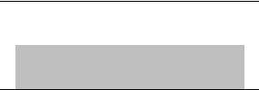



Release of Annual Funds

To the Agency

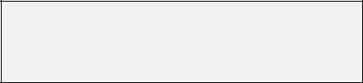

Review By DBT
Committees

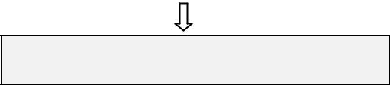
Recommendations

Secretary DBT

Approval



Process for the next Release by DBT

Role of Agency


Updating and Management of Online
Submission & Monitoring System

(OSMoSys)

(Submission, Verification and Tracking of
Status of proposals by users)
(Ref. Appendix I-A)

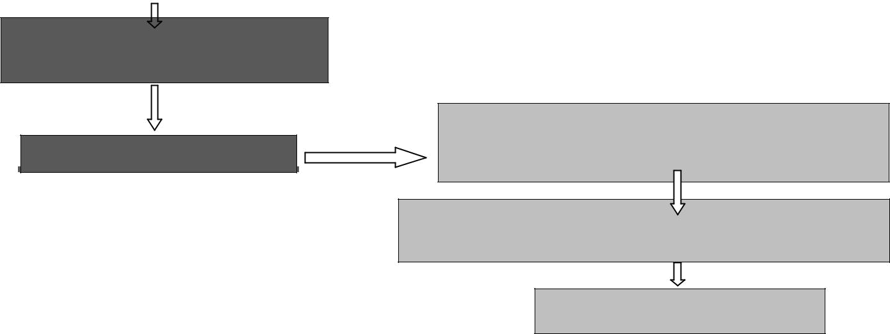


Updation of Decisions

On OSMoSys

Disbursement Of funds To The grantee Institutions

Follows Ups



Submission of Annual Report,
Due & Drawn Statement &

Accounts To DBT (UC & SE)

Appendix I-A

OSMoSys

20

Online Submission & Monitoring System (OSMoSys)

Flow of Activities Built in the Online System
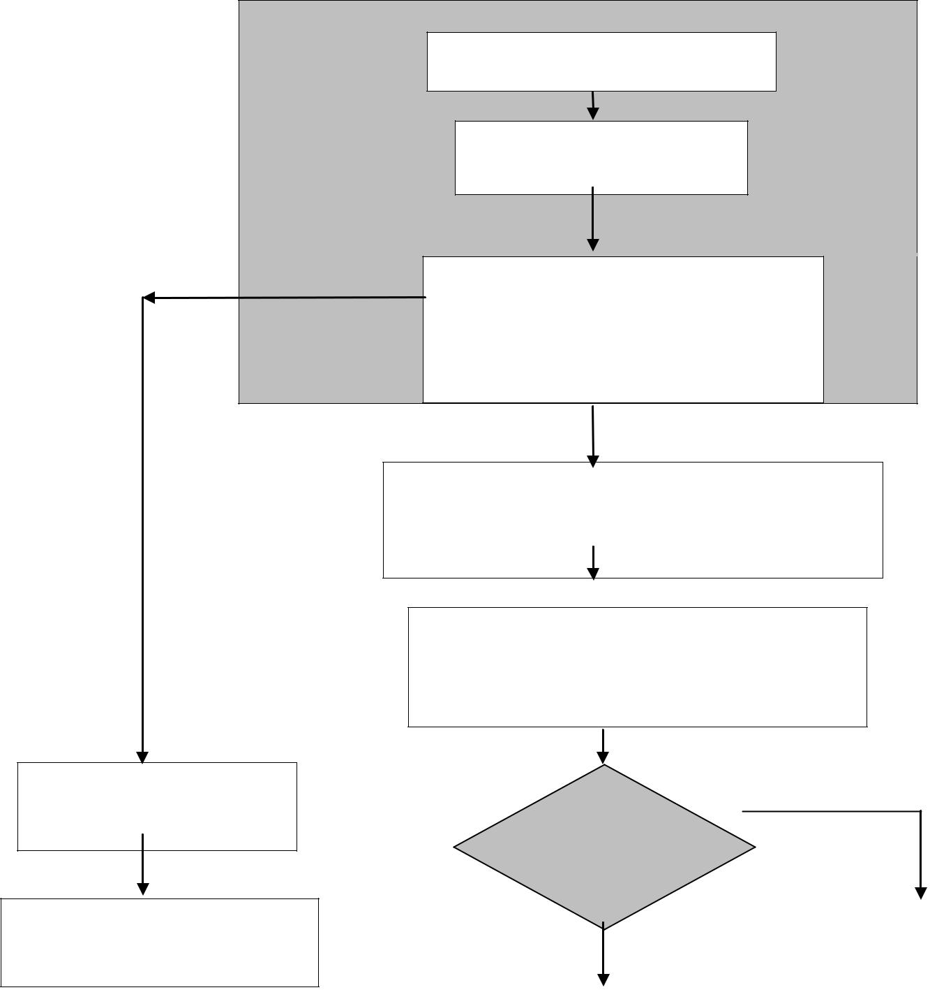

User fills Proforma &
Submits proposal

Uploading of relevant
documents

System generated Unique
Proposal Code to be sent to
users registered email for further
online status enquiry the user for
Further online status enquiry

Proposals to be reviewed by

The DBT Committee based on the agenda provided by the agency.

Decision of all proposals

to be generated as a list for Secretary, Department of Biotechnology approval

User makes a search With the Unique proposal code

System displays the Status detail of the submitted proposal

 | Decision |  |  | NO
 | approved
 |  |  |  | Status updations as
 | YES |  |  | well
 |  |  |  | as System generated
 | Release of budget |  |  | email sent to institute
 | As per the directions of |  |  | stating reason of
 | DBT. |  |  | END
 | Follow ups on OSMoSys |  |  | END


21

Appendix I-B

Details of Activities Performed under DBT-CTEP Program

The Department of Biotechnology (DBT), Government of India provides financial assistance to popularise Biotechnology activities in India for the following types of proposals:

- For holding National/ International-Conference/ Seminar/Symposium/ workshop.

- Foreign Travel support for the researchers towards attending international conference/ seminar/ symposia.

o Organizing exhibitions both in India and abroad.

o For organizing popular lectures by experts in the area of modern biology, Biotechnology and related fields.

The DBT-CTEP Cell is established at the consulting organization for carrying out the various activities related to the programme and consists of few professionals who will execute the various activities related to DBT CTEP listed here and coordinate with DBT on this.

The Online Submission and Monitoring System (OSMoSys) acts as a single window for the submission, processing and settlement of grants. The function-wise operations and maintenance activities to be performed are described in subsequent sections.

Organization registration

- Receiving registration requests and downloading it.

- Verification of documents such as registration certificates, Article of Association, Byelaws and Bank details etc.

- Approving the registration, if documents are correct.

- If documents are incorrect, then need to coordinate with the applicant, till the submission of correct documents.

- On satisfactory compliance and proper verification of documents, organization registration is approved.

Receiving proposals

22
- Receiving online submitted proposals and conducing preliminary examination to move it to next stage i.e. “under consideration”

- Downloading the whole proposal in PDF format and in some instances where PDF is unable to generate, we download the individual documents.

- Numbering the proposals in order.

Scrutinizing proposals

- Going through the proposals and reconciling the entered details with the uploaded documents.

- Scrutinizing documents such as HoD approvals, Technical Programmes, paper acceptances, various Ministry clearances, etc.
- Giving comments/remarks on each proposal.

- Generating draft agenda with all the comments.

- Sending the draft agenda to DBT for correction/edition/suggestion, etc.

- Incorporating the correction/edition/suggestion, etc in final agenda.

- Preparing final agenda.

Meeting Coordination

ECPPB (Experts Committee on Promotion and Popularization of Biotechnology) Meeting

- Circulating hardcopy agenda among the members.

- Noting Minutes of the meeting.

- Preparing draft minutes and sending it to DBT for approval.

- Updating the final minutes on CTEP website with sanctioned amount and committee’s remarks.

DBT-CTEP Review Meetings

- Preparation of MIS reports & presentations such as: o Current year proposals trend.

o Comparative statements.

23
o Funds utilization status.

  - Recommendation status. Etc.

- Noting the suggestions of DBT in the form of Minutes for incorporation in CTEP website.

- Coordinating the comments and suggestions made by DBT to TERI IT team

Settlement of claims

Conference Grant

Processing initial grants:

- Processing initial grants based on Committee’s remarks though automated system.

- Preparing payment lots and reconciling the bank details with that uploaded bank details.

- Coordination with Accounts Department, TERI for release of funds.

- Sending payment advices to successful grant recipients.

- Processing balance grants:

- Scrutinize and orderly arranging the received claims.

- Checking and analyzing Utilization certificates, Statement of income & expenditures and other documents.

- Checking the conformities with the minutes of DCPPB meetings.

- Preparing checklist.

- Coordination with the applicants regarding deviations in the documents.

- Processing the successful claims online.

- Preparing payment lots and reconciling the bank details with that uploaded bank details.

- Coordination with Accounts Department, TERI for release of funds.

- Sending payment advices to successful grant recipients.

24
Travel

- Scrutinize and orderly arranging the received claims.

- Checking and analysing reports and boarding passes and tickets etc.

- Checking the conformities with the minutes of DCPPB meetings.

- Preparing checklist.

- Coordination with the applicants regarding deviations in the documents.

- Processing the successful claims online.

- Preparing payment lots and reconciling the bank details with that uploaded bank details.

- Coordination with Accounts Department, TERI for release of funds.

- Sending payment advices to successful grant recipients.

Disbursement of funds under DBT special sanction order

- Scrutinize and orderly arranging the received claims.

- Checking and analysing all the received documents.

- Preparing checklist.

- Coordination with the applicants regarding deviations in the documents.

- Processing the successful claims and entering the payment details in CTEP website manually.

- Preparing payment lots.

- Coordination with Accounts Department, TERI for release of funds.

- Dispatching payments through ECS/RTGS to ensure successful grant recipients.

Note: The above same method is followed in settlement of Exhibition and Popular

Lecture claims.

Help Desk (inbound/ outbound)

The current operations of Help Desk are as follows:

- Attending inbound calls.

- Occasionally making outbound calls for follow-up purposes.

- Counseling applicants.

25
- Responding to emails.

- Requesting for documents/clarifications and arranging them in order for further action.

Misc. responsibilities

- Coordination with DBT Staff.

- Introducing new features, improvements in the website.

- Follow-ups/ coordination with some applicants as and when instructed by DBT.

- Preparing Utilization certificates and statement of expenditures (annual process)

- Preparing CTEP invoices.

- Any other activity assigned by DBT related to CTEP

26
Appendix I-C

Details of Updation Activities for DBT-CTEP Cell

Entity proposes to establish a robust and feature rich open-source based help desk system to simplify and expedite the support for users. Some of the key features planned to be implemented are as follows:

- The commonly used response should not be typed again but available to send just by one click

- Each ticket raised by user will be assigned priority e.g. high, medium and low

- It should be easy and fast to take various actions on tickets and provide timely support to end-user

- Escalation of issues to senior management if any issue is not addressed within the time limits

- Profile based permissions to users

- The system should develop a Knowledgebase over a period of time for ready reference to support team and end-users

- The system should show the relevant content before a user raises a new ticket to save the time of help desk team

- Users should be able to register a ticket simply by sending an email to DBT-CTEP Management Cell (ctepcell@dbtctep.gov.in)

- Τhe system should send email notifications when a new ticket is raised by a user and also after a response provided by help desk.

27

