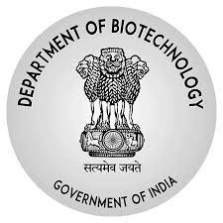 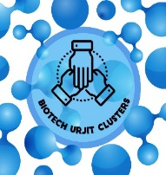

**BIOTECH URJIT CLUSTER**

**Letter of Intent**

1. Lead institute
2. Lead coordinator- name, email
3. List and Name the Participating institutes

(please indicate status – whether the organization is an incubator/research institute/University/Industry)

1. Role and Responsibility of each institute/University/ Industry
2. Core Thematic Areas

Vertical – 1

Vertical – 2

Vertical - 3

1. Plan for taking knowledge through translation to delivery
2. Unique Components of the cluster
3. How will industry be involved
4. How will faculty/researcher be engaged with translational activity
5. How will start-ups be involved, matured
6. Key questions/clarification sought: provide a list of questions that you need clarification from DBT

**Guidelines:**

* Kindly submit the LoI as per the above format in not more than 2 pages to Dr. Kalaivani Ganesan ([k.ganesan@nic.in](mailto:k.ganesan@nic.in)) and Dr. Rajesh Ghangal ([rajesh.ghangal@dbt.nic.in](mailto:rajesh.ghangal@dbt.nic.in))
* The last date is Feb 15th, 2021
* Full length proposals must be submitted by Mar 15th, 2021, online
* Those who submit the LoI will be invited for a pre-proposal meeting with DBT for clarifying queries on full-application proforma