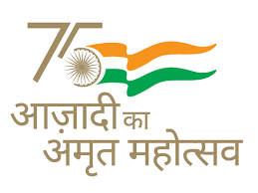
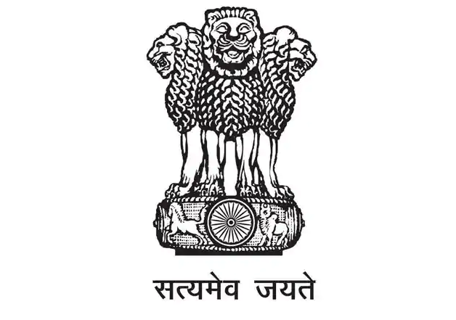
GOVERNMENT OF INDIA
MINISTRY OF SCIENCE AND TECHNOLOGY
DEPARTMENT OF BIOTECHNOLOGY

CALL FOR PROPOSALS
for
Fast Track Development of “Rapid Biodegradability Test for biodegradable plastics” under Environment Biotechnology

Background: Plastic waste is one of the most formidable challenges in today’s world. The government of India has notified the Plastic Waste Management Amendment Rules, 2021, which prohibited the manufacture, import, stocking, distribution, sale, and use of single-use plastics (SUPs), intended to phase out the single-use Plastic Carry Bags of thickness less than 120 microns by December 2022. This has fast-tracked the promotion of the development of biodegradable products to replace the single use plastics. These biodegradable products need the certification of biodegradability. The current biodegradability testing methods are time-consuming hence there is need to develop innovative and rapid test methods at accelerated conditions which can prove biodegradability as per national and international standards. This rapid test should prove biodegradability of plastic in short time using suitable test parameters. The developed test after approval may be applicable to provide interim approval /provisional certification of biodegradable plastic.
Considering the prospects of biotechnological tools, this call for proposal is intended to support the short duration (3-6 Months) project proposals specific to develop the anaerobic/aerobic “Rapid Biodegradability Test” with the potential of scalability and immediate testing application.
KEY DATES:
Activity | Date/Month/Year
Call Opening Date | 21st November 2022
Call Closing Date | 05th December 2022
WHO CAN APPLY: Regular faculty members of recognized universities and academic institutions, scientists working in National Laboratories, R&D institutions, and Research organizations recognized by DSIR, individually or in consortium mode with defined role. The Project investigator should have proven track record and standing in the relevant area of the call, evidenced by the publications/patents etc.
THEMATIC FOCUS AND PRIORITY AREAS:
- Development of Indigenous Anaerobic/Aerobic “Rapid Biodegradability Test” with minimal process duration, for testing biodegradability in less than 45 days or less following the National and Global Standards.
- Scale Up and Technology Transfer following extant rules in this regard.
ASSESSMENT CRITERIA:
- Technical competencies of investigators & Preliminary work in relevant area evident by publications/patents etc.
- Methodology and Work plan
- Availability of minimum required resources and infrastructure
- Timelines and concrete deliverables
- Potential application for scale and commercialization
COMPONENT OF GRANT
- Research Manpower (Nomenclature and salary as per DBT/DST guidelines only)
- Outsourcing /Others
- Domestic travel
- Consumables
- Contingencies
- Other costs
- Overheads as per DBT norms.
PROPOSAL SUBMISSION
Interested researchers should submit short duration (Maximum 6 Months) project proposals online only through DBT electronic project management system ‘eProMIS’ (http://dbtepromis.nic.in/Login.aspx) under the Programme ‘Environmental Biotechnology’.
PROCESSING OF PROPOSAL Upon receipt of the detailed proposal, the same will be reviewed by the Internal Screening Committee. Incomplete applications and those which do not fulfill eligibility criteria will not be considered. Shortlisted applications that are complete and responsive will be evaluated for scientific and technical merit by Technical Expert Committee. The project investigators may be invited to make a detailed presentation before the committee. The decision of the committee on a proposal will be final and communicated to the investigator.
Any technical queries in this regard can be addressed to Dr. Sangita Kasture, Scientist ‘F’ and Head Energy & Environment Decision Unit, Department of Biotechnology, Ministry of Science & Technology, Government of India at Email sangita.kasture@nic.in or Dr. Balendra Singh, Scientist ‘C’ and Programme Officer, Environment Biotechnology, Department of Biotechnology, Ministry of Science & Technology, Government of India via Email: balendra.singh@dbt.nic.in.
In addition, queries/difficulties pertaining to proposal submission through portal to be addressed to eProMIS Team via email epromis.dbt@nic.in
*****

