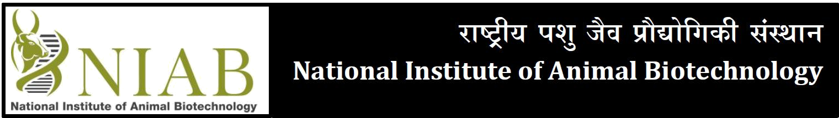
(An Autonomous Institute of Dept. of Biotechnology, Ministry of Science & Technology, Govt. of India)
Sy.No. 37, Opp. Journalist Colony, Extended Q City Road, Gowlidoddi, Gachibowli, Hyderabad, Telangana, India - 500 032 Tel: +91 40 2312 0103, 115; Fax: +91 40 2312 0130;
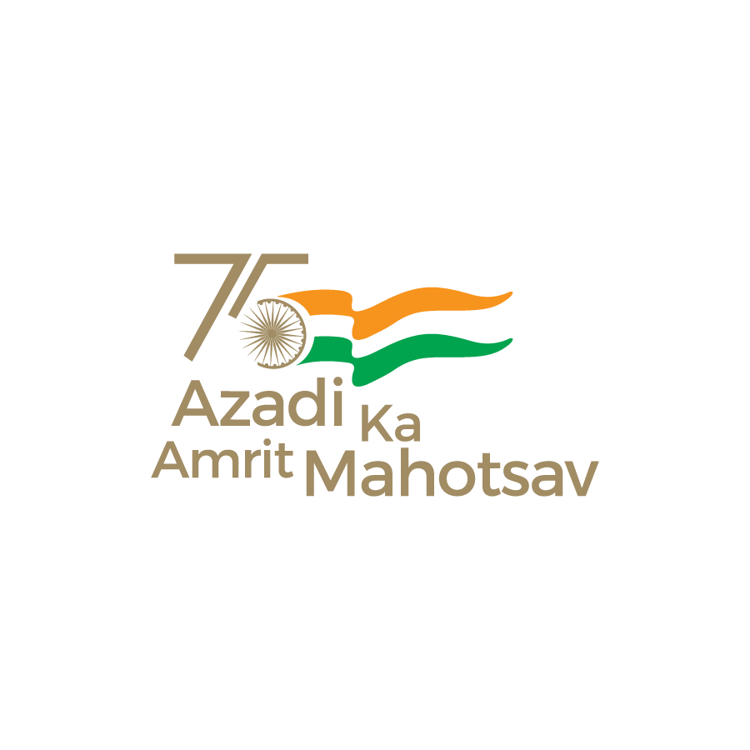
Email: admin@niab.org.in; Web: www.niab.res.in

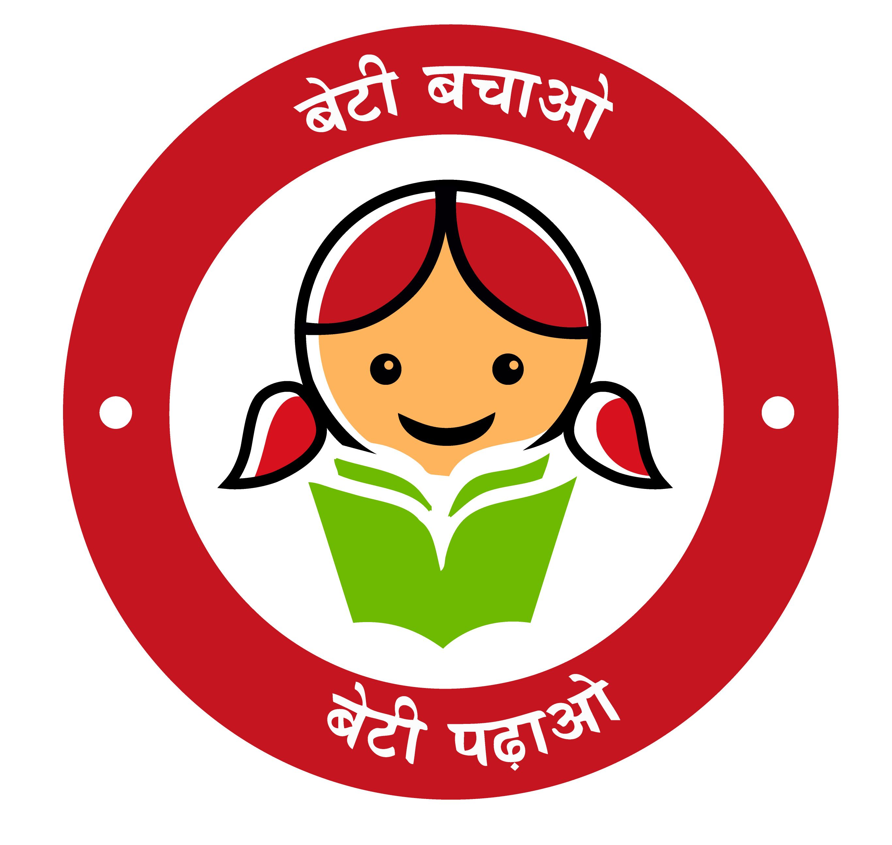

Advertisement No. 29/2023

NIAB, an autonomous institute under the aegis of the Department of Biotechnology, Ministry of Science & Technology, Government of India, is aimed to harness novel and emerging biotechnologies and create knowledge in the cutting edge areas for improving animal health and productivity. The Institute’s research focus is on animal health and production with an special emphasis on Reproductive Biotechnology, infectious biology, Genomics, transgenesis, stem cell biology, nutrition, nanobiology and bioinformatics. The Institute aims at translational research leading to genetic enhancement of Indian Livestock species and basic research towards development of novel vaccines, diagnostics various organoids and improved therapeutic molecules for farm animals.

NIAB invites applications from suitably qualified, dynamic, result oriented and dedicated Indian citizens for filling up the following positions:

Scientist-G – Two posts (1-UR, 1-OBC)
Pay Level | 14 as per 7th CPC
Method of Recruitment | Direct Recruitment / Deputation (ISTC) / Absorption
Age limit | 50 Years for Direct Recruitment  58 Years for Deputation (ISTC) / Absorption
Recruitment on Deputation | Scientists or Technologists working in the Central or State Governments / Universities / recognized Research Institutions / Semi Government, Statutory or Autonomous Organizations in India or abroad  (i) holding analogous posts on regular basis in the parent cadre or Department; or  (ii) with two year’s of service in the grade rendered after appointment thereto on regular basis in Level 13A or equivalent / with three year’s experience in Level 13 or equivalent; and  (b) Possessing the qualifications prescribed for direct recruits, as given below.  The Deputation period will be as per rules of Govt of India.
Essential Qualification | Ph.D in Veterinary / Animal Sciences/Modern Biology/Life Sciences equivalent from a recognised university with a strong track record of research and academic accomplishment in terms of publications and patents and attracting generous research funding. (ii) Evidence of leadership with 10 years of R&D experience in any one of the NIAB Thrust areas.
Job Description | The selected candidates are supposed to work on the health improvement of livestock using modern biotechnological tools and address issues related to infertility linked with animal productivity. In addition to their own research programme, he/she is expected to provide support to other research projects at NIAB and put efforts towards institute building.  The selected candidates are also expected to lead the HRD programme of the Institute. In addition, candidates have to attract extra-mural funding to establish and lead research programs in upstream mandated areas.
Areas in which applications are invited | (i) Reproductive Biotechnology  (ii) Genomics, Genetics with upstream biotechnological tools  (iii) Gene editing, disease model generation, Regenerative medicine, Biotherapy
Published evidence of working in the specified area during after Ph.D. (Publications in high quality journal will be given preference)
WOMEN SCIENTISTS FULFILLING THE REQUIREMENTS ARE ENCOURAGED TO APPLY

Please visit NIAB website www.niab.res.in for futher details.

Important dates

Date of commencement of online applications: 25 Sep. 2023
Last date for submitting online applications: 25 Oct. 2023

Sd/-
Director, NIAB

