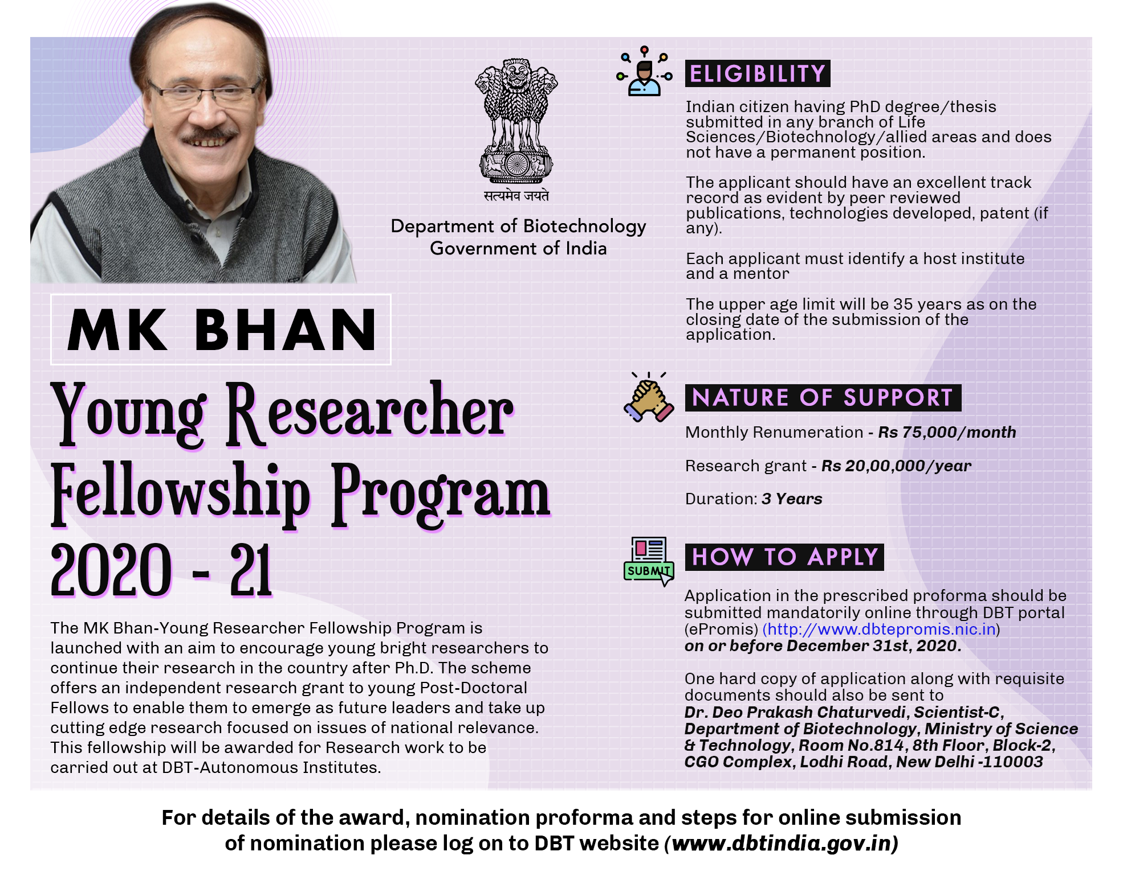

**M K BHAN – YOUNG RESEARCHER FELLOWSHIP PROGRAMME (MKB-YRFP)**

**ABOUT THE SCHEME:**

The Department of Biotechnology (DBT), Ministry of Science & Technology, Government of India, has launched a new grant opportunity, the M K BHAN – YOUNG RESEARCHER FELLOWSHIP PROGRAMME (MKB-YRFP), with an aim to encourage young bright researchers to continue their research in the country after Ph.D. The scheme is to offer an independent research grant to young Post-Doctoral Fellows, so as to enable them to emerge as future leaders and take up cutting edge research focused on issues of national relevance. This fellowship willbe awarded for Research work to be carried out at DBT-Autonomous Institutes only.

AIM OF THE FELLOWSHIP

1. To provide attractive opportunities to young researchers for developing them as independent investigators.
2. This will enable young researchers to pursue their research interests within the country and also develop a critical mass of trained scientists for the country’s research institutions, universities and major new initiative.

**WHO IS ELIGIBLE TO APPLY?**

1. The applicant should be Indian National and possess a Ph.D. in any branch of Life Sciences/ Biotechnology/allied areas.
2. Applicant should not be holding a permanent position in any institute/university.
3. The applicant should have an excellent track record as evident by peer reviewed publications, technologies developed, patent (if any). Those who have submitted their Ph.D. are also eligible to apply; however, fellowship can be implemented only after award of the degree. Applicant should not take-up fellowship at the Institute where he/she has done his/her Ph.D.
4. Each applicant must identify a host institute and a mentor.
5. The upper age limit will be 35 years as on the closing date of the submission of the application.
6. Applicants cannot have more than one fellowship at a given point of time.
7. The application has to be routed through a host institute (DBT Autonomous Institute) chosen by the applicant to take up the fellowship and has to be signed by both, the mentor and head of the institution.
8. In case a fellow is offered a permanent job, he/she can avail only either the fellowship or the salary.
9. The fellowship is co-terminus with the project duration.

**NATURE OF SUPPORT**

1. The scheme provides a consolidated monthly remuneration of Rs. 75,000/- p.m.
2. MKB-YRFP fellows in addition will receive a research/contingency grant of Rs. 20.00 lakh per year for hiring manpower, purchase of consumables, minor equipment, domestic travel and other contingent expenditure to be incurred for the implementation of research proposal selected for the fellowship.
3. Can engage one manpower (JRF/SRF/Project Assistant/Project Associate) under him/her. Capital equipment will be procured in the name of the institute where the fellow proposes towork and value of the whole set of the equipment should not exceed Rs.10.00 lakh.
4. MKB-YRFP fellows will be eligible for regular research grant through extra mural and other schemes of various S&T agencies of the Govt. of India, provided that Co-PI is a regular faculty. However, they can take research grant from anywhere but salary from only one source.

**WHERE WILL THE MKB-YRFP FELLOWS WORK?**

1. MKB-YRFP Fellows can take up the Young Investigator grant at any of the DBT-Autonomous institutions. However, application should be duly forwarded by the competent authority of the host Institute. Fellows can change their host institute only once during the tenure of the fellowship with the prior No Objection Certificate from the host institute who has forwarded the application (Director/Registrar). New institute proposed for change also hasto be a DBT Autonomous Institute.
2. Candidate should submit his/her nomination through single host institute only. However, institutions can nominate more than one candidate.

**DURATION AND NUMBER OF FELLOWSHIP**

1. The duration of the fellowship will be for a period of three years and in exceptional cases the duration could be extended by another two years on a fresh appraisal.

**HOW TO APPLY?**

1. Eligible applicants should submit application as per prescribed proforma to DBT duly forwarded by the Host Institute where they intend to take up fellowship.

MODE OF SELECTION

1. A national-level Selection Committee constituted by the Department of Biotechnology for the purpose will select the final candidates for MKB-YRFP.

**Financial Support**

|  |  |  |
| --- | --- | --- |
| **Non-Recurring** | | |
| **Description** | **Amount** | **Comments and Notes** |
| Equipment and accessories | Up to an amount of Rs. 10.00 lakhs |  |
| **Recurring** | | |
| Fellowship | Rs. 75,000 per month for 3 years | Admissible only to awardees who do not have a regular employment or not in receipt of any other fellowship/salary |
| Manpower (either one JRF or one SRF or one Project Assistant | As per DST O.M. dated Jan 30, 2019 | Qualifications for JRF and SRF are as per DST O.M. dated Jan 30, 2019. Stipends for Project Assistants with a Master’s degree are Rs.15,000/- per month and with Bachelor’s degree is Rs. 12,000/- permonth. |
| Consumables, Contingencies & Travel  (Travel expenditure is to be restricted up to Rs. 50000/- per year.) | Rs. 10.00 lakh per year |  |

**OTHER CONDITIONS**

1. A letter from the mentor, giving consent to provide laboratory space where the applicant desires to work, should be enclosed with the application. The laboratory should be able to support major needs of the project.
2. Fellows are not entitled to any kind of salary during the fellowship. If during the fellowship, the fellow finds a regular employment in DBT AIs or receives any other fellowship, he/she should immediately inform to the DBT. In that case fellow has an option for taking either salary or fellowship at a given point of time. However, he/she can continue to avail research grant for the remaining duration of the fellowship. If fellow accepts a permanent position in other than DBT AIs, he/she needs to opt out of the MKB-YRFP fellowship.
3. The financial transactions of the award programme will be to be handled by the host institute, which will be responsible for submitting the Utilization certificate (UC) and Statement of Expenditure (SE) every financial year.
4. Each Institute will be sanctioned a consolidated budget for the number of fellows selected for each Institute. Budget will include the Fellowship amount and Contingency/Research Grant.
5. The awardees will be the corresponding author for any publication emanating as a result of the research carried out on account of the award. The mentor and others could be co-authors. The support of DBT should be suitably acknowledged in the publications (papers, reports etc.) arising out of the research work done under this award programme.
6. The Fellow will submit annual progress report through Host Institute.
7. Institute will constitute an Expert Review Committee to review the scientific work done by the Fellow and submit minutes of the Review Committee to the DBT along with UC/SE.

**\*\*\*\*\*\*\*\*\*\*\*\*\*\*\*\***

DEPARTMENT OF BIOTECHNOLOGY (DBT)

**APPLICATION FOR M K BHAN-YOUNG RESEARCHER FELLOWSHIP PROGRAM2020(MKB-YRFP)**

**MKB-YRFP -2020-21**

**(Expand space wherever needed)**

|  |  |  |  |  |  |
| --- | --- | --- | --- | --- | --- |
| ***1.*** | ***Full name*** |  | | | |
| ***2.*** | ***Date of Birth & Age as on 31st December, 2020 (attach proof for age)*** |  | | | |
| ***3.*** | ***Gender (Please***  ***tick the relevant box)*** | Male |  |  | Female |
| ***4.*** | ***Full postal address*** |  | | | |
| ***5.*** | ***Home Telephone*** |  | | | |
| ***6.*** | ***Work Telephone*** |  | | | |
| ***7.*** | ***Mobile*** |  | | | |
| ***8.*** | ***Fax*** |  | | | |
| ***9.*** | ***E-mail address*** |  | | | |

### Designation

1. ***Name and address of the forwarding Institution***
2. ***Academic qualification from Bachelor’s degree onwards***

|  |  |  |  |  |
| --- | --- | --- | --- | --- |
| Degree | Subject | University/institution | Year | Percentage of marks &  Class/Grade |
|  |  |  |  |  |
|  |  |  |  |  |
|  |  |  |  |  |
|  |  |  |  |  |

* 1. ***Positions held: (list the most recent first)***

|  |  |  |
| --- | --- | --- |
| Position | University/Institution | Dates |
|  |  |  |
|  |  |  |
|  |  |  |
|  |  |  |
|  |  |  |

* 1. ***Details of PhD work***

|  |  |
| --- | --- |
| Title |  |
| Institution/University |  |
| Name of Mentor |  |
| Mentor’s e-mail ID |  |

* 1. ***Details of:***
     + 1. ***Work done during PhD (not more than 300 words)***
       2. ***Work done during Post-doctoraltraining (if any) including institute where work was carried out, name & email id of mentor and brief description (not more than 300 words) of work.***
  2. ***List of peer reviewed publications in indexed journals giving list of authors (indicate whether applicant is first or corresponding author), name of journal, journal impact factor, year of publication, volume and page numbers.***
  3. ***List of any books/chapters/reviews published***
  4. ***Overseas visits***

|  |  |  |  |
| --- | --- | --- | --- |
| Name of the place | Country | Duration of the visit with dates | Purpose |
|  |  |  |  |
|  |  |  |  |

* 1. ***Awards won***

|  |  |  |
| --- | --- | --- |
| Awarding Agency or organization | Purpose | Nature of the award |
|  |  |  |
|  |  |  |
|  |  |  |

* 1. ***Details of Research Proposal***
     1. ***Area of Research***
     2. ***Project Title***
     3. ***Scientific details of research project (Description should not exceed 5 pages)***

*The description must be confined to the following details:*

* *Introduction,*
* *Background to the problem,*
* *Objectives,*
* *Working hypothesis,*
* *Detailed Methodology,*
* *Expected outcome.*

### Name & address of the mentor

|  |  |
| --- | --- |
| **Full name** |  |
| **Title** (Professor/Dr) |  |
| **Position:** |  |
| **Institution’s address:** |  |
| **Telephone** |  |
| **E-mail address** |  |

|  |  |
| --- | --- |
| ***Name of head of the organization / duly designated competent forwarding authority*** |  |
| ***Name*** |  |
| ***Designation*** |  |

* 1. ***Any other information in support of your application***

Attachments Needed

1. Proof for date of birth.

2. Proof of Master’s degree, and PhD Certificate.

3. One copy of each publication mentioned in column 16 and 17.

4. One copy of award details mentioned in column 19

5. Consent form from mentor (as case may be) and host institute

I confirm that all the information provided in the application is factual and true to the best of belief. I have checked the research proposal for plagiarism and confirm that any similarity is within acceptable limits. Further, I also understand that if any deviation from this is detected and confirmed, my application is liable to be rejected or if this occurs after award, the same will be withdrawn.

SIGNATURE OF THE APPLICANT NAME DATE:

PLACE:

-------------------

**DECLARATION/CERTIFICATION**

It is certified that

* 1. If the project involves the utilization of genetically engineered organisms, we agree to submit an application to DBT duly approved by our Institutional Bio- safety Committee. We also declare that while conducting experiments, the Bio-safety Guidelines of the Department of Biotechnology would be followed.
  2. If the project involves field trials, human subjects, animal experiments, exchange of biological specimens etc. we will ensure that appropriate ethical clearances would be taken from concerned ethical Committees/Competent authorities. These details will be conveyed to the Department of Biotechnology before implementing the project.
  3. If the Research Project involves biological resources, the obligations under the Biological Diversity Act 2002 as applicable shall be compiled with the awardee, the details of such obligations can be accessed at www.nbaindia.org
  4. It is agreed that any intellectual property right(s) on the invention(s) arising out of the project shall be taken in accordance with the instructions and guidelines of the Department of Biotechnology. Please see www.dbtindia.gov.in for details.
  5. The Institute undertakes all needed financial and other management responsibilities of the project.
  6. The mentor will provide all necessary support to the awardee (those not in regular/permanent employments) as per the guidelines given in the MKB-YRFP notification.
  7. The institute will provide necessary facilities for carrying out the research by the MKB-YRFPfellow.

## -------------------------- ----------------------------------

|  |  |
| --- | --- |
| **Signature of mentor with seal bearing name, designationand affiliation** | **Signature of Competent Authority**  **Institute /University seal bearing**  **name, designation and affiliation** |