**DEPARTMENT OF BIOTECHNOLOGY,**

**GOVERNMENT OF INDIA**

**&**

**MINISTRY OF SCIENCE AND ICT,**

**REPUBLIC OF KOREA**

**INDIA-KOREA JOINT PROGRAMME OF COOPERATION**

**IN SCIENCE & TECHNOLOGY**

**India-Korea Joint Network Centre**

***Call for proposals***

***Proposals to be submitted by 6:00 pm (local time)on May 29, 2020***

**1. Objectives**

This Call for Proposals is to enable Indian and Korean scientists from academia and laboratories to carry out joint research activity by leveraging already existing infrastructure and funding available with the partners at both sides through a linkage established by a **Joint Network Centre (JNC)**. Joint Network Centre aims to encourage joint project implementation on focal areas of thematic and knowledge research through networking thus, paving way to sustainable interactions by promoting excellence and developing long term relationship based on synergy of activities. Network Centre may also provide opportunities for integrating research with education.

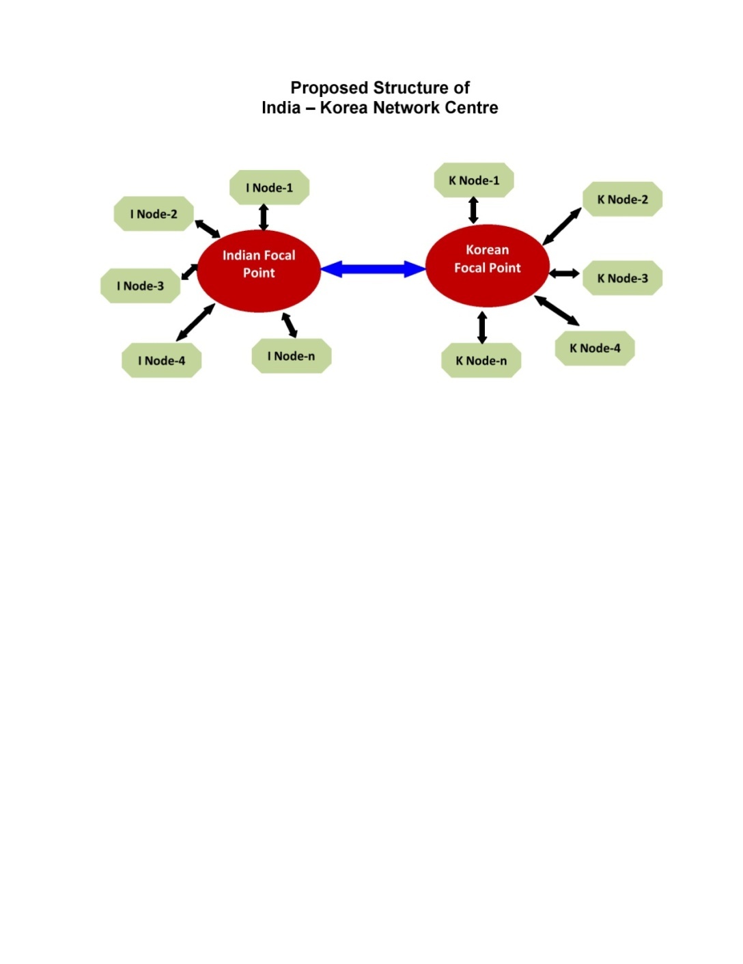

**Structure of the JNC**

**2. Potential Area of Cooperation**

Department of Biotechnology (DBT), Government of India, Ministry of Science and ICT (MSIT)of the Republic of Korea invite Indian and Korean research groups to submit proposals for **Joint Network Centre** in the following area:

***Artificial Intelligence utilization in the field of Biotechnology***

**3. Activities of the JNC**

*When the focal coordinator draws up the proposal of JNC, the below details may be included*.

* Exchange of Researchers, Research students and Post-Doctoral scholars
* Joint Seminar/Workshop/ Hands on training School *(one in each country per year)*
* Joint Research

*When the focal coordinator draws up the proposal of JNC, the below details may be targeted to be delivered as outcomes*.

* Publish joint papers
* Develop Prototype / Processes
* Promoting pre-commercial R & D activities

**3. Eligibility Requirements**

1. One focal lead coordinator each from India and Korea.
2. Minimum of two Indian and two Korean separate institutional node partners, except the focal point institute (3+3 partnership mode). However, there can be more than two node partners on each side as well.
3. The Focal Coordinator and node partners should either be scientists, researchers, or faculty members employed by government-recognized universities, academic institutes or national research and development laboratories or institutes.
4. If interested, Industries can also participate with their own funding, but they will not be counted as either the focal coordinators or node partners.
5. All partners to have intellectual and financial stake in the Joint Centre activities.
6. Proof of existing funding support available towards infrastructure and equipments has to be provided with the proposal.

☞ For both Korean and Indian sides, intellectual property and financial issues should comply with domestic regulations.

**4. Programme Requirements**

* The Focal Coordinators are responsible for submitting annual scientific and financial reports in order to ensure continued funding.
* Focal Coordinators are also responsible for the technical and administrative coordination of Network Centre.
* Neither Focal Coordinator / Node Partner should be retired or planning to retire during the proposed duration of the Proposal.

☞ For both Korean and Indian sides, the project should be carried out in accordance to respective domestic regulations.

**5. Kind of support available for Joint Project**:

Only one Network Centre per research area will be selected for funding. Each selected Joint Network Centre will be funded for a period of up to three years. However, both sides must pass the annual evaluation in each country for continuation of funding. Expenditure by JNC in their country would be borne by the respective country, i.e., DBT would support expenditure on Indian side of the JNC whereas MSIT would meet the expenditure of Korean side.

On the Korean side, MSIT’s tentative funding amount for each Network Centre would be approximately 60,000,000 won per year.

On the Indian side, DBT will provide funding support to Focal Coordinating Indian Institute. Funds to other Indian nodes of the JNC would be provided through the Focal Indian Institute of the JNC. From DBT following financial support can be provided to each JNC:

* **Research Manpower:** Maximum One JRF / SRF/ Research Associate for each node. In addition, one suitable man power can be provided to the Focal coordinator for coordination of the activities.
* **Research Expenses:** Upto Rs. 5 lakh to each Indian node towards consumables.
* **Joint Workshop& Training School:** Financial support for organizing one joint workshop cum hands on training school each in India and Korea with participation of 15 -20 students of host country every year may be provided to the Focal coordinator of the JNC.
* **Support for Exchange visit component:** Two visits from each side each year for each node of the JNC can be funded. The sending side will provide round-trip economy-class airfare to the relevant entry city of the host country as well as medical insurance. The receiving side will provide accommodation and living expenses, i.e., transportation including pick-up service to and from the airport, food, etc.
* **Institutional Overhead:** Institutional Overhead and contingency support will be determined in accordance with specific norms of DBT.
* **Participating Indian institutions are responsible for expenses regarding equipment**.

☞ All expenditures must be agreed upon by both parties in the available budget. Since the budget regulations of the two sides are different, consultations must be made within their respective rules.

**6. Proposal Submission**

**Korean and Indian Focal Coordinator shall write a common application to be submitted to both DBT and NRF. The common application must be written in English. It will be responsibility of the Focal coordinator to collect technical and financial details from each associated nodes while writing the proposal.**

The Indian applicants for funding can download the proposal formats from website http://www.dbtindia.gov.in and should submit completed application form and all relevant information in PDF format through E-mail at garima.g@nic.in. Proposals must be submitted in the format at http://www.dbtindia.gov.in. Indian Applicants are also requested to send **three hard copies** to DBT (Dr. Garima Gupta, Scientist E, DBT) **by May 29, 2020 18:00** through proper channel**. Proposals not submitted through E-mail or hard copy by due date will not be considered. DBT will not be liable for any postal delay.**

☞ All proposals must be submitted by the deadline, taking into account the time difference between the two countries.

It should be ensured that application with identical title has been submitted by the Korean Focal Coordinator to NRF by due date/time**.**

For Korean applicants, a separate application form written in Korean is also required. Please refer to ‘call for proposals’ for instructions on completing the Korean-language proposal **(Korean side only).**

**7. Assessment of applications**

All applications received by the notified deadline will undergo a peer review process of evaluation and then referred to an independent advisory panel for consideration and ranking. Applications must attain a positive rating to be considered eligible for funding. Joint selection of successful application by DBT and NRF will be discussed by the respective nodal agencies. Decisions made by the India-ROK Joint S&T Committee will be final. The following criteria will be taken into consideration for selection of proposals:

* Scientific merit / Scientific excellence of the proposal
* Synergy / Complementarity aspects between the collaborating nodes
* Mutual advancement of research through the transfer of knowledge and expertise
* Ability of the teams to successfully complete the project
* Expected research outputs
* Perceived advantage(s) for both Indian and Korean sides
* Participation of Industry and potential towards applied research and product development.

**8. Time schedule**

**The time schedule of 2020 JNC program is as follows:**

* From March 25 to May 29 2020 : Announcement of the call and submission
* By the early June 2020 : Exchange the submission list
* By the early August 2020 : Evaluation
* By the mid September 2020 : Discussion/Final decision for selection
* By the end of September : Contract/Financial support at each side
* 1st October 2020 : Commencement of the research projects

**9. Contact Information**

|  |  |
| --- | --- |
| **DBT (INDIA)** | **MSIT- NRF(KOREA)** |
| Dr. Garima Gupta  Scientist ‘E’, HRD Division,  Department of Biotechnology,  510, 5th Floor, Block 2, CGO Complex, New Delhi-110003  Tel: 011-24369385  Email: [garima.g@nic.in](mailto:garima.g@nic.in) | Ms.Jihye Shin  Senior Researcher  Asia Cooperation Team  Center for International Affairs  National Research Foundation of KoreaTel : +82-2-3460-5676  E-mail :[sophie1207@nrf.re.kr](mailto:sophie1207@nrf.re.kr) |

*ANNEXURE - I*

**Application form for Joint Programme of Cooperation in science and technology**

1.Name of Joint Network Centre

|  |
| --- |
|  |

2. Duration

|  |
| --- |
| /　　/　～　　　/ /　　(dd/mm/yyyy)(Years & Months) |

**※Duration should be 3 years (i.e., 36 months) all together.**

3. Contact Information of Lead Focal Coordinator

|  |  |  |
| --- | --- | --- |
|  | ***INDIA*** | **KOREA** |
| **Name of Focal Coordinator** |  |  |
| Organization |  |  |
| Department |  |  |
| Title |  |  |
| Address of Institution |  |  |
| Office phone # |  |  |
| Cell phone # |  |  |
| Fax # |  |  |
| e‑mail |  |  |
| Date of Birth |  |  |

4. Contact Information with affiliation of all participating Nodes

(Minimum 2 nodes from each side)

|  |  |  |
| --- | --- | --- |
|  | ***INDIA*** | **KOREA** |
| Name of Node Partner |  |  |
| Organization |  |  |
| Department |  |  |
| Title |  |  |
| Address of Institution |  |  |
| Office phone # |  |  |
| Cell phone # |  |  |
| Fax # |  |  |
| e‑mail |  |  |

|  |  |  |
| --- | --- | --- |
| Name of Node Partner |  |  |
| Organization |  |  |
| Department |  |  |
| Title |  |  |
| Address of Institution |  |  |
| Office phone # |  |  |
| Cell phone # |  |  |
| Fax # |  |  |
| e‑mail |  |  |

5. Executive Summary of the Proposal

|  |  |  |  |
| --- | --- | --- | --- |
| **Keywords** |  |  |  |
|  |  |  |
|  |  |  |
| **Objectives** |  | | |
| **Approach** |  | | |
| **Expected Outcome** |  | | |

**※ Attention - font: Times New Roman, size: 11 points / Do not exceed space provided.**

6.Background and introduction of the subject area including state of the art in India and South Korea (upto200 words)

|  |
| --- |
|  |

7.Aims and Objectives of the Joint Network Centre

|  |
| --- |
|  |

8. Details about the partnering Nodes in the JNC (Please specify role and responsibility of each Indian and Korean Nodes alongwith synergy / complementarity)

|  |
| --- |
|  |

9.Plan of work(*per annum*)

|  |  |  |
| --- | --- | --- |
| Timeline | **Responsibilities of Indiannode** | **Responsibilities of Korean node** |
| 1stYear  (yyyy) |  |  |
| 2ndYear  (yyyy) |  |  |
| 3rdYear  (yyyy) |  |  |

10. Details about sharing of facilities / manpower and other stakes by the partners:

|  |  |
| --- | --- |
| At the Collaborating Indian Institutions | At the Collaborating Korean Institutions |
|  |  |

11. Justification for collaboration

|  |
| --- |
|  |

12. Proposed mechanism for IPR sharing

|  |
| --- |
|  |

13. Expected outcome specifically in terms of furthering bilateral cooperation / interactions and other substantive follow-ups. Expected results likely to have commercial value.

|  |
| --- |
|  |

14. Proposed monitoring / reporting mechanism for the Joint Network Centre

|  |
| --- |
|  |

15. Personal Data of Indian and Korean Focal Coordinator to be attached.

**※Describe the expertise in the proposed field of workby citing relevant publications. Do not exceed one pageA4 size for each Coordinator(Font: Times New Roman, size: 11 points).**

16. Research History of both Focal Co-ordinator.

**※ Describe major scientific publications, patent applications and ongoing / completed national / international projects during the last 5 years. Do not exceed one page A4 size for each PI (Font: Times New Roman, size: 11 points).**

17. Personal Data and Research History of Indian and Korean Node Partner to be attached.

**※Describe the expertise in the proposed field of work by citing relevant publications / patents, and ongoing / completed national / international projects during the last 5 years. Do not exceed one page A4 size for each Node Partner(Font: Times New Roman, size: 11 points).**

18. Number of exchange visits required to achieve the objectives by all Partners (Year wise)

|  |  |  |  |  |
| --- | --- | --- | --- | --- |
|  | **INDIA TO S. KOREA** | | **S. KOREA TO INDIA** | |
|  | Number of persons x visits | Duration for each person’s visit | Number of persons x visits | Duration for each person’s visit |
| 1st Year |  |  |  |  |
| 2nd Year |  |  |  |  |
| 3rd Year |  |  |  |  |

18. Joint Workshops cum hands on training school proposed to achieve the objectives by all Partners (Year wise)

|  |  |  |  |  |  |  |
| --- | --- | --- | --- | --- | --- | --- |
|  | **In India** | | | **In South Korea** | | |
|  | Number of Korean Speakers | Number of Indian Speakers | Number of Indian Students | Number of Indian Speakers | Number of Korean Speakers | Number of Korean Students |
| 1st Year |  |  |  |  |  |  |
| 2nd Year |  |  |  |  |  |  |
| 3rd Year |  |  |  |  |  |  |

**FINANCIAL INFORMATION**

**Consolidated Budget Plan–Total proposed Budget on Indian side**

(All *costs should be in INR for proposal submitted by Focal Coordinator. Budget of all Indian nodes must be included while seeking the financial support)*

**(Rs.)**

|  |  |  |  |
| --- | --- | --- | --- |
|  | 1st Financial Year | 2nd Financial year | 3rd Financial Year |
| Consumables |  |  |  |
| Manpower |  |  |  |
| Contingency |  |  |  |
| **Exchange Visits** | | | |
| Indian Scientists to Korea |  |  |  |
| Korean Scientists to India |  |  |  |
| Workshop in Korea |  |  |  |
| Workshop in India |  |  |  |
| Training School |  |  |  |
| **Total** |  |  |  |

**Budget plan of Individual Indian Focal Coordinator and Nodes**

(All *costs should be in INR Budget of each Indian Nodes and Focal Coordinators should be prepared separately under this head.*

**(Rs.)**

|  |  |  |  |
| --- | --- | --- | --- |
|  | 1st Financial Year | 2nd Financial year | 3rd Financial Year |
| Consumables |  |  |  |
| Manpower |  |  |  |
| Contingency |  |  |  |
| **Exchange Visits** | | | |
| Indian Scientists to Korea |  |  |  |
| Korean Scientists to India |  |  |  |
| Workshop in Korea |  |  |  |
| Workshop in India |  |  |  |
| Training School |  |  |  |
| **Total** |  |  |  |

* Please provide quantified list of consumable items
* Full justification should be given for each budget head
* Please note that failing to provide quantified list of consumables and full justification, the support for consumables would not be considered by the evaluation Committee.

A. Signatures of the Nodal Partners

**▶ Indian PI**

Name Signature Date ________

**▶ Indian PI**

Name Signature Date ________

**▶ Korean PI**

Name Signature Date ________

**▶ Korean PI**

Name Signature Date ________

B. Signatures of the Focal Coordinators&Institutions

**▶ Indian**

Name Signature Date ________

**▶Korean**

Name Signature Date ________

C. Declaration from the Heads of the Focal Collaborating Institutions

It is certified that

1. the Institutions agree to participate in this Joint Research Project;
2. the Institutions shall provide necessary facilities for implementing the Joint Research Project;
3. the Institutions assume financial & other management responsibilities for the duration of the project to be carried out at their institution; and
4. the back‑up funding for manpower, consumable etc. is available for this Joint Research Project.
5. the Institutions shall ensure that funding agencies are duly acknowledged in publications and all forms of scientific communications arising out of the collaboration
6. the Institutions shall ensure that necessary approval from Institutional Ethics Committee have been obtained for carrying out experiments, wherever applicable, as per the law of the land.

Signature of the Heads of the Institutions

**▶ Head of the Indian Institution**

Name Signature Date

**▶Head of the Korean Institution**

Name Signature Date