Indian Biological Data Centre (IBDC) : A wealth of information, representing scientific disciplines in the healthcare, genomics, proteomics, metabolomics, microbiomes, protein structures, natural compounds, agriculture and population genetics, is being generated in India. However, in the absence of any central data repository for national biotechnology data, both sharing and data-dependent research are restricted. Therefore, it is imperative that India puts the right infrastructure to store, manage, archive and distribute all biological data (Figure 1). DBT has established the Country's First National Indian Biological Data Centre (IBDC) for deposition, storage, annotation and sharing of biological data generated in the country through extensive funding from various Government Organizations.

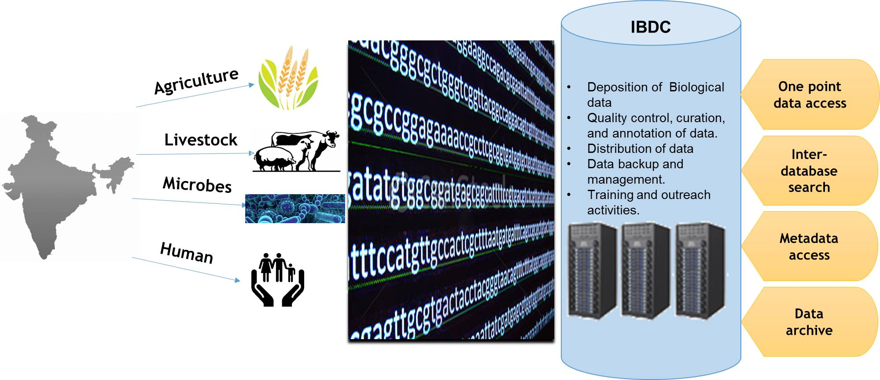
Figure 1: Impact of “Indian Biological Data Centre”

The Indian Biological Data Centre will have the following four major Objective :
- Setting up the required IT platform (hardware/software) for storage/distribution of biological data and development of appropriate web portal for data deposition/retrieval. It will enable researchers to deposit biological data in IBDC and store all biological data in the country perpetually.
- Development of standard operating Procedures (SOPs) and training of staff for storing the data as per FAIR principle, performing quality control, curation/annotation of data, data backup and management of data life cycle.
- Development/Installation of softwares for analysis of stored datasets by researchers on IBDC portal and development of web based tools/APIs for data sharing/retrieval.
- Organization of training programs on high throughput data analysis and performance of outreach activities for sensitizing researchers on benefits of data sharing.

The IBDC will enable life science researchers to deposit biological data in a central repository and thus safeguard data generated using public resources from loss. It will perform quality control, curation, and annotation of data. These efforts will help establish benchmarks for the quality of data deposited and thus improve the quality of experimental research conducted in the country. It will also facilitate distribution of biological data to researchers for further analysis and the discovery of emergent properties in biological systems. IBDC will also conduct training programs on data storage and analytics to help increase the number of manpower skilled in Data Science in the country.

